Project:
Fredericton Junction Emergency Services Complex
Title: Exterior Perspective View
No. 4

DIMENSIONS
Scale:
Date: 14-11-25
Drawn by: S. Corey
Drawing No:
4−5

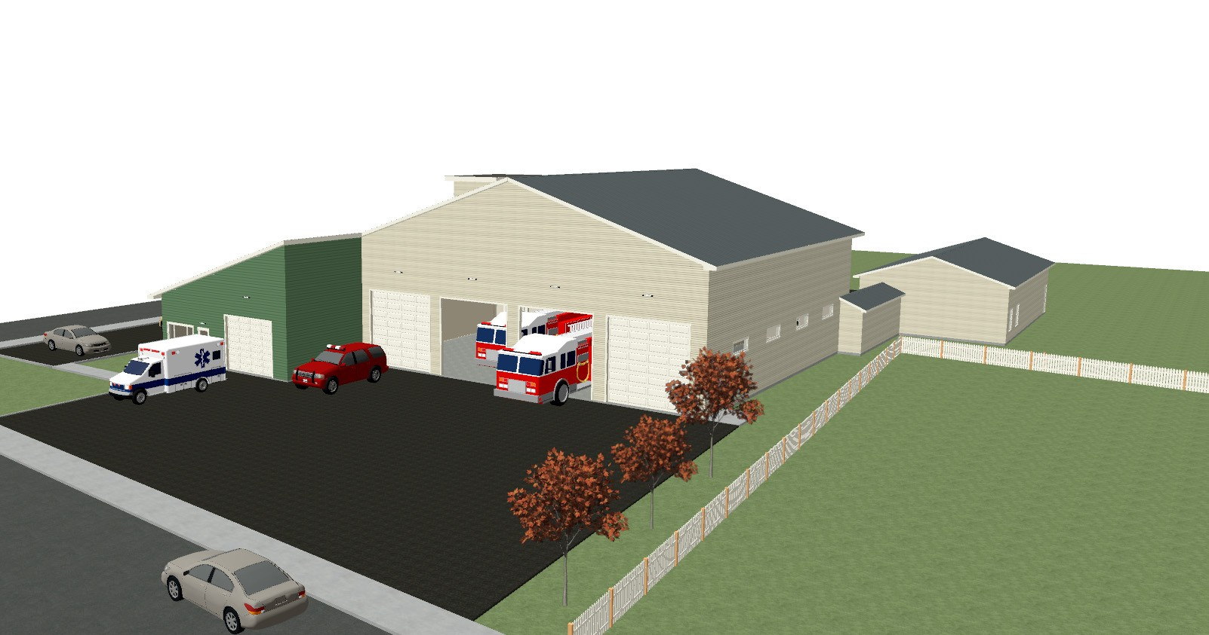t 506-471-2010
f 506-472-0278
e ddd@rogers.com
89 Katie Ave
Douglas, NB E3G 9K7
Drafting
and Design

