Storage Garage
29'-0" x 18'-0"
Storage
3'-8" x 11'-7"

DN Bunk Rm #2
16'-8" x 8'-0"

Maintenance
Bunk Rm #1
7'-11" x 19'-0"
Platform

Chief's Office Comm. Rm. W/R
Future Use
32'-0" x 19'-0"
9'-6" x 10'-4"
9'-6" x 10'-4"
8'-7" x 6'-4"

Hose Tower
(Open below)
Training Room
29'-0" x 34'-5"
Connecting Corridor
7'-0" x 28'-0"

UPPER LEVEL
Utility Rm.
6'-6" x 6'-0"

UP
Mech.
12'-0" x 6'-11"

Existing Municipal
Office Building
ENTRY
10'-0" x 16'-4"
Female W/R
13'-4" x 8'-0"

Kitchen/Lounge
16'-2" x 19'-0"

Male W/R
16'-9" x 0'-10"

Equipment Rm
12'-0" x 11'-8"

Drying Room w/ Hose Tower
10'-0" x 8'-10"

Fire Hall Bays
68'-11" x 49'-5"

Washroom
8'-8" x 8'-9"
Multi-Use Rm
11'-6" x 8'-1"
Mech
6'-9" x 8'-1"

Office
8'-8" x 9'-11"
Storage
17'-2" x 5'-11"

Computer
8'-8" x 7'-5"

Kitchenette/Lounge

14'-0" x 26'-10"

Ambulance Bay
18'-6" x 33'-4"
Project:
Fredericton Junction Emergency Services Complex
Title:
Main and Upper
Level Floor Plans

DIMENSIONS
Scale: 3/32" = 1' - 0"
Date: 14-11-25
Drawn by: S. Corey
Drawing No:
5−5

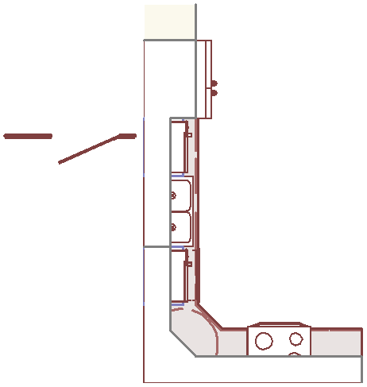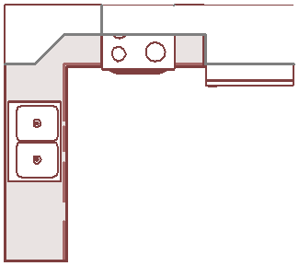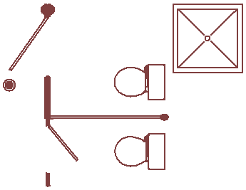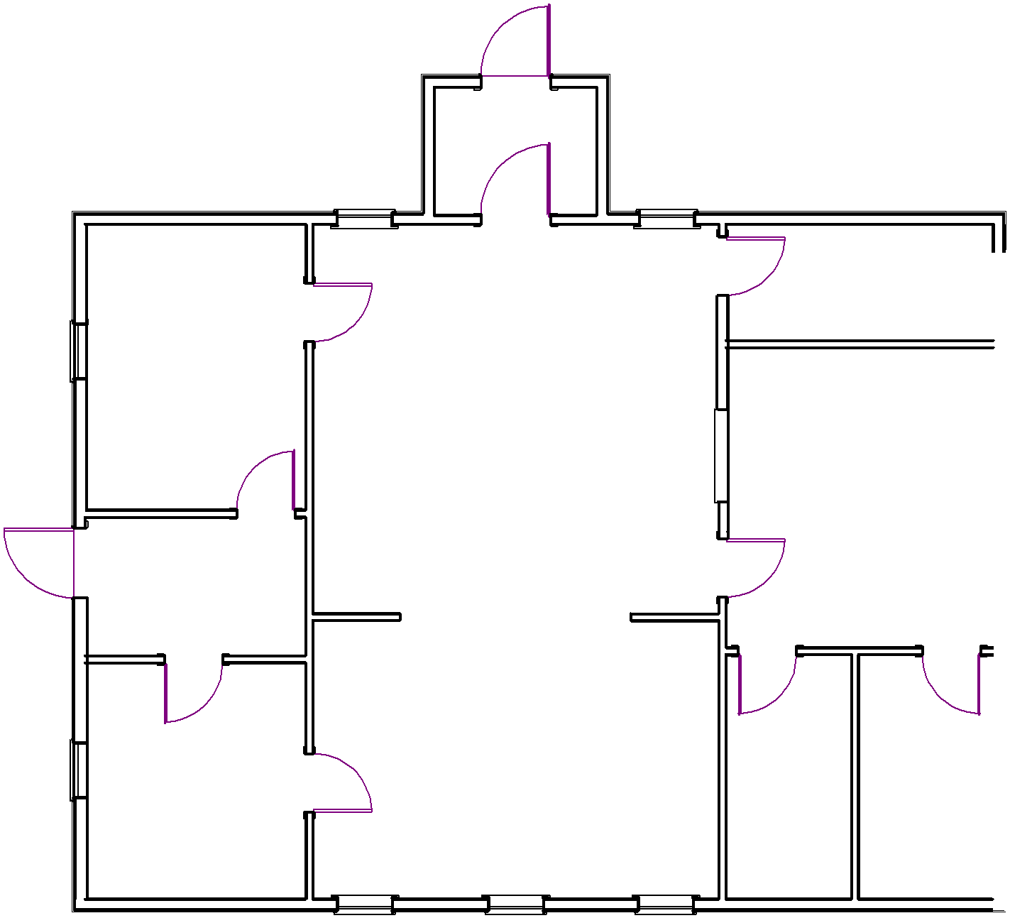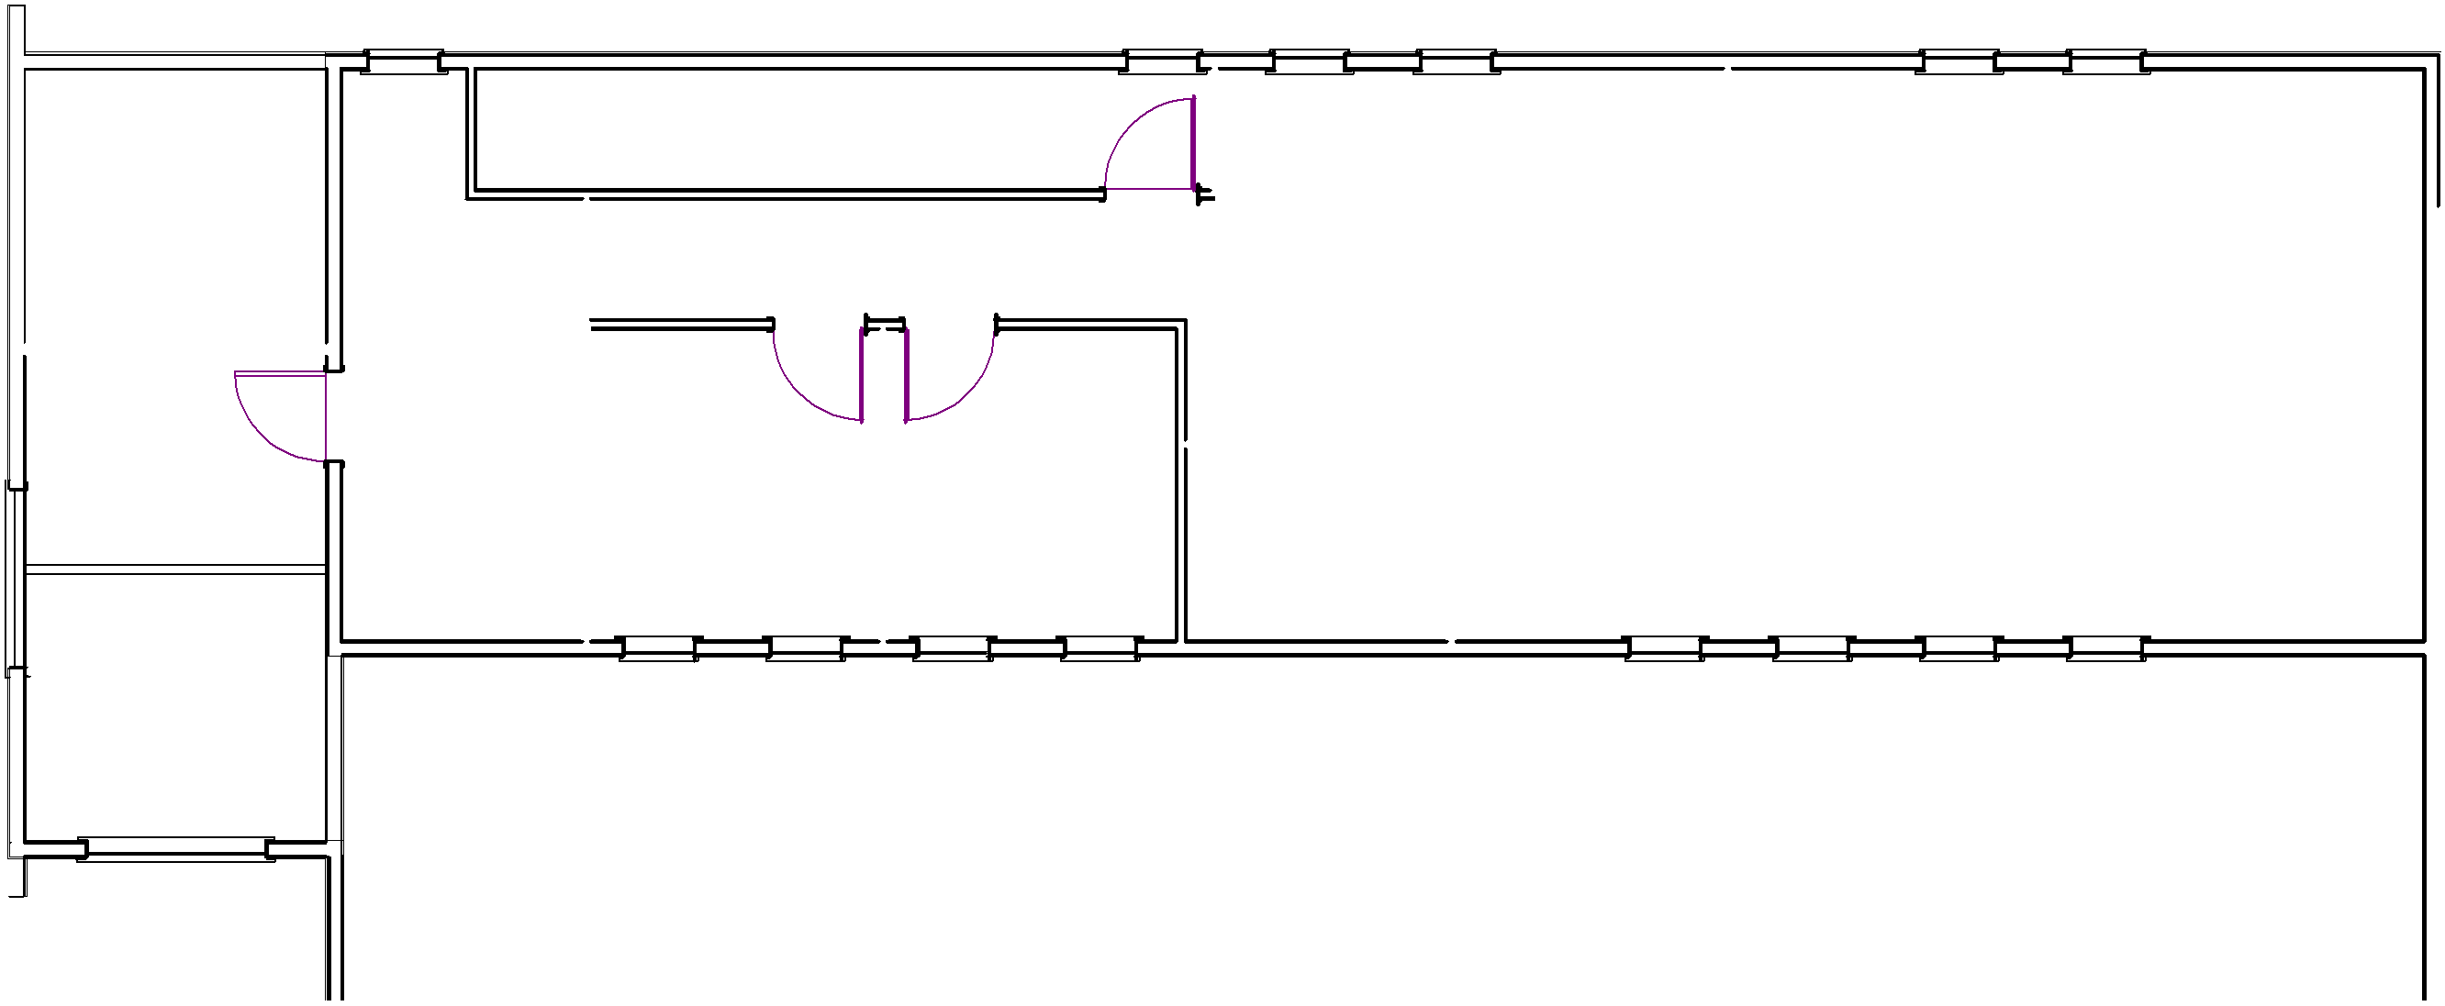MAIN LEVEL

t 506-471-2010 f 506-472-0278
e ddd@rogers.com

89 Katie Ave Douglas, NB E3G 9K7

Drafting and Design

